8 July 2019
Dear Parents, Carers and Colleagues
Braunton Learning Co-operative
On Thursday 4 July 2019, governors from all six schools met to consider the views and comments received during the statutory consultation process about the proposal to set up the Braunton Learning Co-operative. Following individual Board meetings, we are pleased to inform you that each Governing Board voted to implement the proposal from 1 September 2019.
This will mean that Caen Community Primary School, Kingsacre Primary School, Marwood School and Southmead Primary School will change their legal school category from community to foundation and, at the same time, acquire charitable status as a shared co-operative Trust.
Braunton Academy and Georgeham C of E (VC) Primary School have voted to become partner schools within the Trust.
We would like to thank everyone who participated in the process and look forward to sharing our plans for 2019/20 following our first Trust Board meeting at the beginning of October.
Yours sincerely

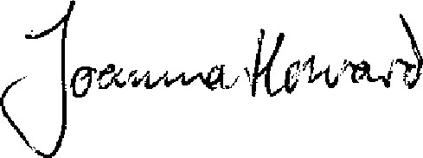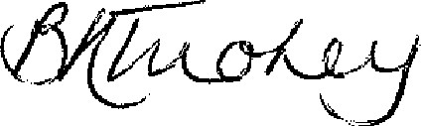
Joanna Howard Briony Tuohey
Chair of Governors Chair of Governors
Caen Community Primary School Kingsacre Primary School

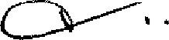
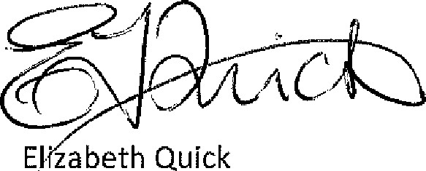 Marguerite Shapland

Chair of Governors Chair of Governors
Marwood School Southmead Primary School

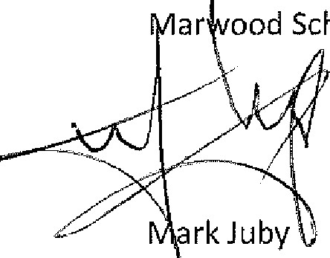
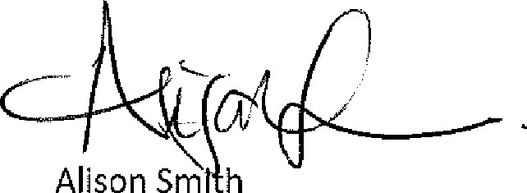
Chair of Governors Chair of Governors
Braunton Academy Georgeham C of E Primary School

